DNA Fingerprinting Quiz Name:___________________________________

1. You are using a restriction enzyme that cuts at the CCGG. Cut between the C and G. It does not leave sticky ends. Show where it would cut on this DNA strand. Count the number of base pairs in each band. Using a chart like the one below the DNA strands mark draw the bands for each of the strands of DNA shown.

Suspect 3
GTCGACCGGTGACCGTGCGTACACAGTGCTCCGGATAGCTGATAGCTCCGGTG CAGCTGGCCACTGGCACGCATGTGTCACGAGGCCTATCGACTATCGAGGCCAC

Suspect 4
GTCTCCATCCGGACTACCATACATCTGGTGTACCCGGTGATATCGTCCGGGTG CAGAGGTAGGCCTGATGGTATGTAGACCACATGGGCCACTATAGCAGGCCCAC

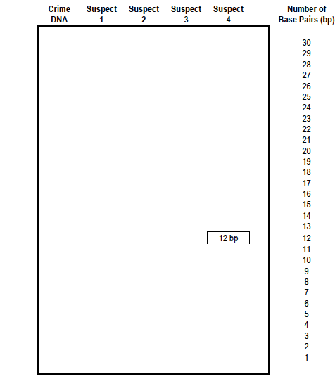

2. The following DNA sequence is from a virus that is dangerous, scientists want to use a restriction enzyme to cut the virus into bits. They do not need sticky ends because the do not plan to combine it with other DNA. The enzyme used cuts at the CCGG sequence between the C and G. Show how this DNA would be cut on the DNA below.
3. How many pieces would you have? ________

4. How long (number of base pairs) is each of the fragments?

ACGCCGGCCGTATTAT CCGGATCCGCCG CCGGCTGTCCCGGATCA TGCGGCCGGCATAATAGGCCTAGGCGGCGGCCGACAGGGCCTAGT

5. Two enzymes cuts at the following location GTC ↓GAC and CC ↓ GG . Show how the DNA would be cut on the DNA below.
ACGGTCGACACGTATTATTAGTCGACTCCGCCGCCGCCGGTCATCA
TGCCAGCTGTGCATAATAATCAGCTGAGGCGGCGGCGGCCAGTAGT
6. How many pieces would you have? ________

7. How long (number of base pairs) is each of the fragments?

8. What is the purpose of heating the DNA and the enzyme?

9. Is the DNA molecule negatively or positively charged?

10. Why do we use a restriction enzyme during DNA fingerprinting?

11. How many samples of DNA should go in each well in the gel?

12. After DNA samples are loaded into the sample wells, they are “forced” to move through the gel matrix. What size fragments (large vs. small) would you expect to move toward the opposite end of the gel most slowely? Explain.

13. Unfortunately three babies have got muddled up at the maternity ward at Altru. Can you analyze the DNA fingerprints below and determine which baby goes with which parents?

14. Explain why not all the bands in the mother’s or father’s profiles have a counterpart in the baby’s DNA profile.

15. The mother in couple B is suing the father in couple A for child support for Baby 4 could Baby 4 be the child of the father in couple A? Explain?

